**STOP/INTREPID Teleconference: Wednesday, September 20, 2023, 1:00-2:00 pm**

# Land Acknowledgment:

* Identify the land you are joining us from today ([**https://www.whose.land/en/**](https://www.whose.land/en/))
* Video: [Bringing meaning and purpose to land acknowledgements](https://www.facebook.com/CentreforAddictionandMentalHealth/videos/bringing-meaning-and-purpose-to-land-acknowledgements/759567845184040/)

Summary of August 2 meeting:

* Review of upcoming STOP Portal data partition; STOP news updates; [**Clinical guidance for e-cigarette (vaping) cessation: results from a modified Delphi panel approach**](https://doi.org/10.1016/j.pmedr.2023.102372)

**Teleconference schedule updates:**

* Beginning on November 1, we will be shifting to **one regular teleconference** per month (1st Wednesday of each month)
* These will use the **same meeting link** (*will be sent before the Nov 1 teleconference*)
* We may still schedule irregular meetings throughout the year

# TEACH Updates:

* [TEACH Core Course](https://teach.camhx.ca/moodle/enrol/index.php?id=113) (Oct 4-Nov 8, $475)
* [Self-study courses](https://teach.camhx.ca/moodle/)

# STOP Updates:

# STOP at Long Term Care Homes – [(click here for poster)](https://www.nicotinedependenceclinic.com/en/stop/Documents/LTC%20Poster.pdf)

# Long Term Care Homes (LTCH) can partner with STOP to provide residents with up to 26 weeks of no-cost Nicotine Replacement Therapy, plus access training opportunities available for practitioners

# Support is also available for community agencies assisting LTCH wait-listed residents, such as Home and Community Care organizations

# If you are a LTCH interested in implementing the STOP Program, please email us at [stop.ltc@camh.ca](mailto:stop.ltc@camh.ca) and [click here](https://edc.camhx.ca/redcap/surveys/?s=LE478TREKDRNFHXM) to complete a capacity assessment survey

# Operations Manuals (all organizations) – updates

# NRT product recalls

# Available on [practitioner resource page](https://www.nicotinedependenceclinic.com/en/stop/implementer-resources) shortly

# STOP logo/icon ideas

* We are planning to rebrand the STOP Program logo and have asked practitioners for suggestions or ideas for what symbol/icon to use.Some of the suggestions include:
  + Healthy/pink lungs,
  + bridge, a path, stepping stones, something to symbolize connection/not just a stop but the start of something
  + hand in a stop gesture,
  + Maybe avoid using a human figure as many clients may not fit the ‘healthy look’
  + Consider engaging a patient advisory group for their ideas as well

# If you have any other ideas for logos, please feel free to email us! We welcome your creativity ☺

**PLEASE READ: STOP data partitioning v2.0:**

* As per our REB requirements, STOP *Program* records (August 27, 2022 and later enrollees) **should not** be stored alongside STOP *Study* records (August 26, 2022 and earlier enrollees). The STOP *Study* records must be kept in a separate offline database (CAMH Team access only)
* In order to fulfill these requirements while ensuring minimal interruptions to clinical care, the transfer of STOP *Study* data to the offline database is being done in two phases:

**~~Phase 1:~~** ~~All~~ ***~~completed~~*** ~~study enrollments (any enrollees from July 28, 2021 and earlier).~~ *~~We completed this on Oct 21, 2022.~~*

**Phase 2: Study enrollments from July 29, 2021 to August 26, 2022) will be transferred once their enrollment period is complete.** *This transfer scheduled for Sep 27, 2023.*

Please see visual below for an overview of the data partitioning timelines.

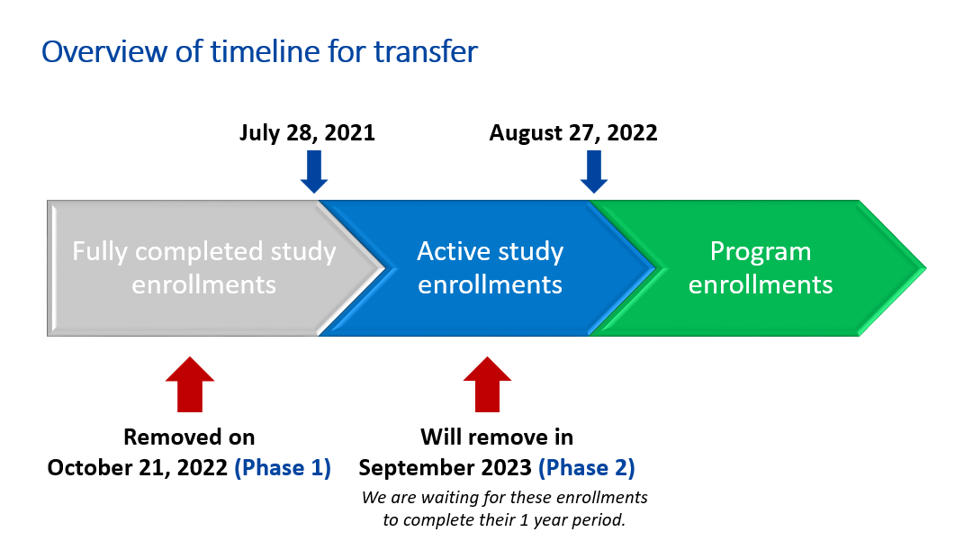

**What does this mean for you?**

* **As of September 27, 2023** all participants who enrolled on August 26, 2022 or earlier will no longer be accessible via the STOP Portal:
* This includes any visits/follow-ups tied to the participant’s enrollment (even if they took place after August 26, 2022)

**In the STOP Portal, these participants *will not be included* in:**

* Patient Searches
* Dashboard enrollment summary & list of recent encounters
* Feedback reports
* Note: NRT Order records on or before August 26, 2022 will be removed
* Note 2: Inventory Log section for old visits will remain available in a limited form – you will be able to see the NRT given out and date, but not the participant’s ID

**What can I do to prepare?**

* Your organization should **download feedback reports** for these data (July 29, 2021 – August 26, 2022 data will be removed)
  + Note: Feedback reports will continue to remain available in the STOP Portal for enrollments from August 27, 2022 onwards
* Count your inventory and make sure all visits are entered and all past orders are accepted!
* Note: we will be sending notifications to all organizations that their Study agreements will end Sep 26, 2023; if you are currently enrolling patients, you don’t not need to do anything as you already have a Program agreement which took effect Aug 27, 2022

General Q&A:

**Q: Does anybody have a sample medical directive that includes multiple allied health professionals, e.g., social workers, harm reduction workers, etc. that they are willing to share?**

A: Some sites have directives that include registered nurses, occupational therapists, respiratory therapists, pharmacists, etc. Practitioners also showed interest in receiving these directives.

**Q: We currently have the promotional poster for STOP on the Net; however, we are hoping to have something smaller (more handout-style) for events we attend. Is this something you have or can create? Or if we created something, would that work?**A: We have business cards available for clients. This contains information about Stop on the Net. Also, we can send promotional material at your request which could be made available to clients.

**Q: Do you have posters for the STOP Program, as well as STOP on the Net?**

A: Yes, please contact STOP and we can send posters, or other promotional material.

**Q: Does STOP on the Net also ship inhalers to patients?**A: No, inhalers are not included in the STOP on the Net Program

**Q: Some of our practitioners try to complete the surveys and notice that the STOP Program staff have completed some. However, others are ‘incomplete’ when they are not doing it. Which is the correct answer?**

A: Generally, follow-ups are done through emails and calls to clients. Not many follow-ups occur at the 3-month compared to subsequent months (6- and 12-month follow-ups). We will include instructions on how to get more feedback.

News:

### Resources:

**STOP Practitioner Resources Webpage**:

[**https://www.nicotinedependenceclinic.com/en/stop/implementer-resources**](https://www.nicotinedependenceclinic.com/en/stop/implementer-resources)

[**Get support with these mental health resources - Kids Help Phone**](https://kidshelpphone.ca/)

# Quote of the day (HCCF participant):

*I smoke only two, three cigarettes, not even, sometimes only smoke one, you know, and I used to smoke two packs a day, and now I'm down to like three. That's a miracle in itself, and it's all because I reached out and I went to the program, the STOP program. And they're just so supportive, man. If it hadn’t been for them, I probably would be smoking my two packs a day. So I'm just – it's one of the best programs I've ever been to, really. I'm not trying to make them look all good and – but it's just – it's good. I'm happy that I found them, and I really … I'm so grateful. I really am.*

# 2023 teleconference schedule:

|  |  |  |  |
| --- | --- | --- | --- |
| ~~January 11~~ |  | ~~February 1~~ | ~~February 15~~ |
| ~~March 1~~ | ~~March 15~~ | ~~April 5~~ | ~~April 19~~ |
| ~~May 3~~ | ~~May 17~~ | ~~June 7~~ | ~~June 21~~ |
| ~~July 5~~ | ~~July 19 cancelled~~ | ~~August 2~~ | ~~August 16 cancelled~~ |
| ~~September 6~~ | ~~September 20~~ | **October 4** | October 18 |
| November 1 | ~~November 15 cancelled~~ | December 6 |  |

Fun Story:

[The CDC says the healthiest vegetable is...](https://www.delish.com/food-news/a44712978/watercress-healthiest-vegetable/)

* [List of healthiest fruits and vegetables](https://www.cdc.gov/pcd/issues/2014/13_0390.htm)

Fun Poll:

***Are you a pumpkin spice person?***

* ***Yes 27/66 = 41%***
* ***No 27/66 = 41%***
* *No strong opinion 12/66 = 18%*

# Attendance:

# Anishwabe Mushkiki AHAC

# Algoma PHU

# Algonquin FHT

# Arnprior and District FHT

# Athens FHT

# Bancroft FHT

# Barrie Native Advisory Circle

# Black Creek CHC

# Blue Sky FHT

# Burk’s Falls FHT

# Carea CHC

# Carefirst FHT

# Casey House

# Centretown CHC

# Chatham-Kent CHC

# Chatham-Kent FHT

# Choices for Change AA

# City of Kawartha Lakes FHT

# City of Lakes FHT

# CMHA Algoma

# CMHA Huron Perth

# CMHA Ottawa

# CMHA Toronto

# De dwa da dehs nyes AHAC

# Dufferin Area FHT

# Fort William FHT

# Georgian Bay FHT

# Grand Bend Area CHC

# Grandview Medical Centre FHT

# Haldimand FHT

# Hamilton-Niagara CHC

# Haven Toronto

# Humber River FHT

# KFL&A PHU

# Kingston CHC

# Kirkland District FHT

# Lakeview FHT

# Leeds and Grenville FHT

# Maitland Valley FHT

# Middlesex-London PHU

# N’Mninoeyaa AHAC

# Niagara North FHT

# Niagara Region PHU

# North Bay NPLC

# North Durham FHT

# Northumberland FHT

# Northwestern PHU

# Ottawa Valley FHT

# Owen Sound FHT

# Peterborough FHT

# Peterborough Networked FHT

# Prince Edward FHT

# Queen’s Square FHT

# Rainbow Valley CHC

# Rideau CHC

# Sandy Hill CHC

# Scarborough A FHT

# Scarborough CHC

# Seaway Valley CHC

# Simcoe Muskoka PHU

# Six Nations AHAC

# Smithville FHT

# Somerset West CHC

# Southwestern PHU

# Stratford FHT

# Sudbury PHU

# Summerville FHT

# Sunset Country FHT

# Superior FHT

# Taddle Creek FHT

# Thamesview FHT

# Thunder Bay PHU

# Tsi Kanonhkhwatsheri:yo

# Twin Bridges NPLC

# Two Rivers FHT

# Upper Canada FHT

# Vitanova Foundation

# West Champlain FHT

# West Elgin CHC

# Women’s College Hospital FHT